October 2018 Activities
SUNDAY | MONDAY | TUESDAY |  | WEDNESDAY | THURSDAY |  | FRIDAY | SATURDAY
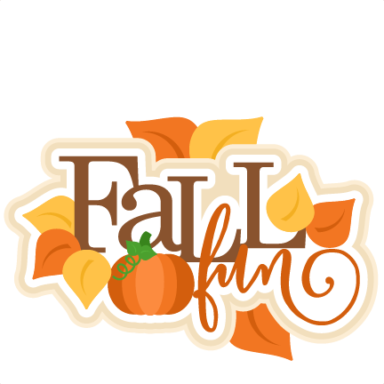 | 1  9:00am Exercise  10:00am Coffee or Mass  2:00am BINGO! | 2  9:00am Exercise  10:00am Coffee  2:00pm Music by The German Singers |  | 3  9:00am Exercise  10:00am Coffee  2:00pm Music by  Larry RIce | 4  World Animal Day!  9:00am Exercise  10:00am Coffee  2:00pm Afternoon Drive |  | 5  World Teacher’s Day!  9:00am Exercise  10:00am Coffee  2:00pm Teacher Appreciation Party! | 6  10:00am Coffee  1:30pm BINGO!
7  Margene Pavlik’s Birthday!  3:00pm Catholic Communion  3:00pm Prayer Service w/ Pastor Neal | 8  9:00am Exercise  10:00am Coffee or Mass  2:30pm Music by The Sandhillers | 9  9:00am Exercise  10:00am Coffee  2:00pm BINGO! |  | 10  9:00am Exercise  10:00am Coffee  2:00pm Estes in Fall Videos & Pumpkin Pie!  6:30pm Music by  Tim Javorsky | 11  9:00am Exercise  10:00am Coffee  10:45am Shopping  2:00pm Manicures or Cards |  | 12  9:00am Exercise  10:00am Coffee  2:00pm Afternoon Drive | 13  Marie Vollbracht’s Birthday!  10:00am Coffee 1:30pm BINGO!
14  3:00pm Catholic Communion  3:00pm Prayer Service w/ Pastor Clark | 15  9:00am Exercise  10:00am Coffee or Mass  2:00pm BINGO! | 16  9:00am Exercise  10:00am Coffee  2:00pm Music by  Anna Mary |  | 17  9:00am Exercise  10:00am Coffee  2:00pm October  Birthday Party  3:00pm Resident Council  6:30pm Country Cloggers | 18  9:00am Exercise  10:00am Coffee  10:45am Shopping  2:00pm Fall Craft  7:00pm KC BINGO! |  | 19  9:00am Exercise  10:00am Coffee  2:00pm BINGO! | 20  10:00am Coffee & Piano Recital by  Anna Mary’s Students  2:00pm Movie or Cards
21  3:00pm Catholic Communion  3:00pm Prayer Service w/ Pastor Brock | 22  9:00am Exercise  10:00am Coffee or Mass  2:00pm BINGO! | 23  9:00am Exercise  10:00am Coffee  1:30pm Music by  Tim Mohanna |  | 24  9:00am Hearing Aid Checks!!  9:00am Exercise  10:00am Coffee  2:00pm Music by  Modern Kowboy | 25  Lois Berggren’s Birthday!  9:00am Exercise  10:00am Coffee & Music by Paul Ramp  10:45am Shopping  2:00pm Afternoon Drive |  | 26  9:00am Exercise  10:00am Coffee  2:00pm Manicures  or Cards | 27  10:00am Coffee  1:30pm BINGO!
28  3:00pm Catholic Communion  3:00pm Prayer Service w/ Pastor Dorn | 29  9:00am Exercise  10:00am Coffee or Mass  2:00pm Afternoon Drive! | 30  9:00am Exercise  10:00am Coffee  1:30pm Music by  Cindy Boehler |  | 31  Happy Halloween!!  9:00am Exercise  10:00am Coffee  2:00pm Halloween Party! | October Resident Birthdays  10/7 Margene Pavlik  10/13 Marie Vollbracht  10/25 Lois Berggren  Staff Birthday: 10/30 Dana Ackles
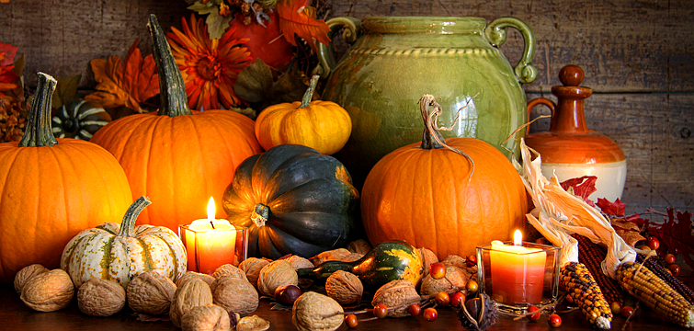 |  |  | 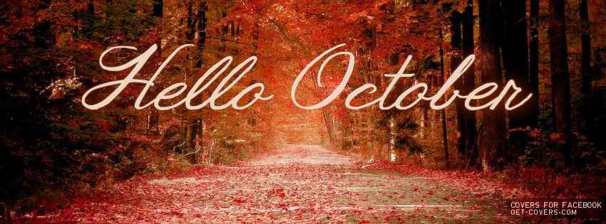
October 2018 Menu
SUNDAY | MONDAY | TUESDAY |  | WEDNESDAY | THURSDAY |  | FRIDAY | SATURDAY
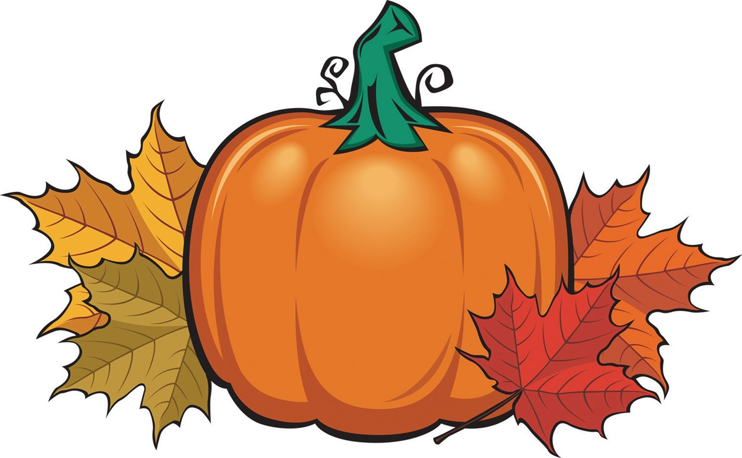 | 1  Spaghetti w/ Meat Sauce  Alaskan Salmon Fillet  Broccoli Cheese Soup | 2  Chicken Alfredo  Swiss Steak  Chicken & Rice Soup |  | 3  Turkey & Dressing  Baked Ham  Tomato Soup | 4  Beef Tips over Noodles  Chicken Fried Steak  Vegetable Soup |  | 5  Brisket  Liver & Onions  Beef Barley | 6  Hamburger Steak  Baked Chicken Fillet  Ham & Bean Soup
7  Bacon Hamburger  Fried Chicken  Taco Soup | 8  Shepherd’s Pie  BBQ Chicken Fillet  Wisconsin Cheese Soup | 9  Chicken Cordon Bleu  Cabbage Rolls  Chicken Noodle Soup |  | 10  Baked Pork Steak  Baked Ham  Tomato Soup | 11  Fried Shrimp  Meatloaf  Potato Soup |  | 12  Turkey & Dressing  Chicken Fried Steak  Beef Noodle Soup | 13  Stuffed Peppers  Baked Cod Loin  Chili
14  Hot Beef Sandwich  Lasagna  Chicken Tortilla Soup | 15  Roast Pork Loin  Baked Cod Loin  Broccoli Cheese Soup | 16  Baked Chicken Fillet  Baked Pork Steak  Chicken & Rice Soup |  | 17  Tacos  Crispy Chicken Sandwich  Tomato Soup | 18  Shrimp Chef Salad  Beef Stew  Vegetable Soup |  | 19  Liver & Onions  Brisket  Beef Barley Soup | 20  Waffles  Sloppy Joes  Ham & Bean Soup
21  BBQ Chicken Fillet  Alaska Salmon Fillet  Taco Soup | 22  Hot Turkey Sandwich  Meatballs & Mushroom Gravy  Wisconsin Cheese Soup | 23  Ham & Cheese Quiche  Lasagna  Chicken Noodle Soup |  | 24  Goulash  Roast Pork Loin  Tomato Soup | 25  BBQ Ribs  Chicken Pot Pie  Potato Soup |  | 26  Pot Roast  Baked Chicken Fillet  Beef Noodle Soup | 27  Fried Chicken  Baked Cod Loin  Chili
28  Baked Pork Steak  Porcupine Meatballs  Chicken Tortilla Soup | 29  Spaghetti w/ Meat Sauce  Alaskan Salmon Fillet  Broccoli Cheese Soup | 30  Chicken Alfredo  Swiss Steak  Chicken & Rice Soup |  | 31  Turkey & Dressing  Baked Ham  Tomato Soup | October Fun Facts:  Those born in October are said to be nature lovers, born leaders, honest, rebellious at times, dedicated and hardworking!!
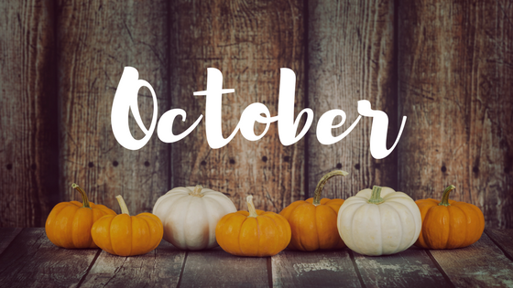 |  |  | 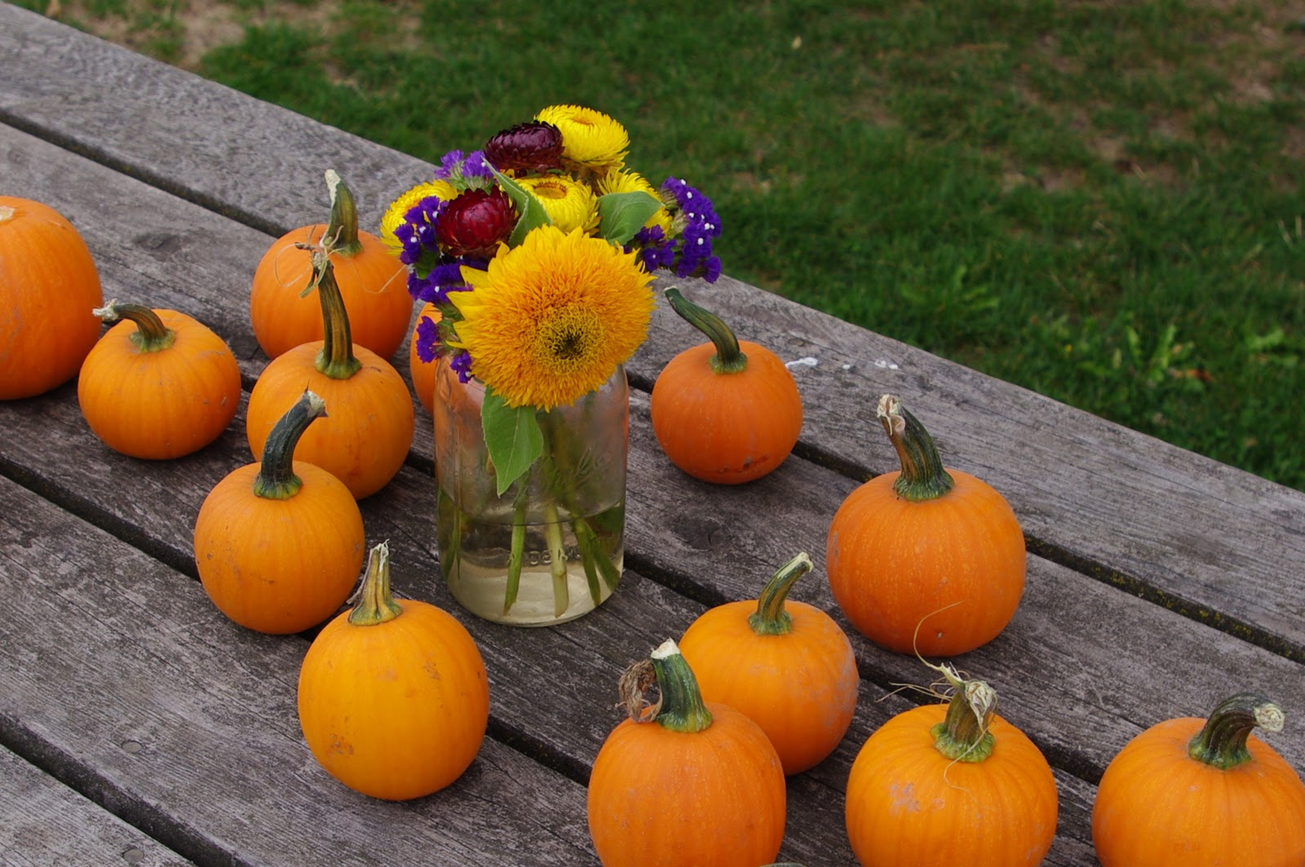 |  |  | 