March 2018 Activities
SUNDAY | MONDAY | TUESDAY |  | WEDNESDAY | THURSDAY |  | FRIDAY | SATURDAY
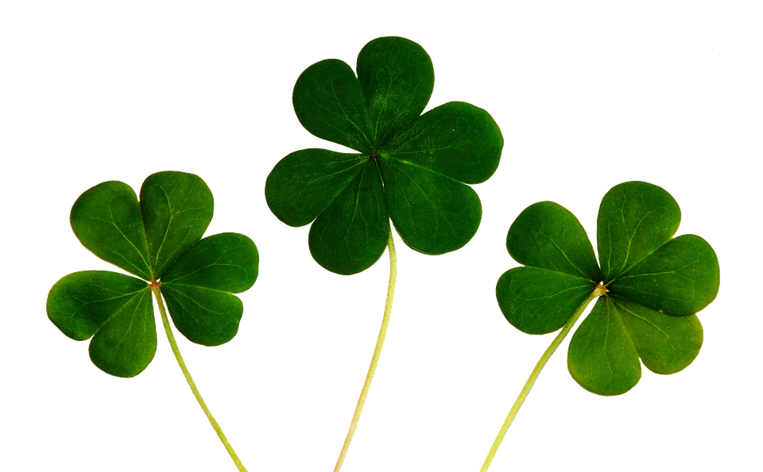 Luck is what happens when  preparation meets opportunity. |  |  |  |  | 1  9:00am Exercise  10:00am Coffee  10:45am SHOPPING  2:00pm Cards &  Board Games |  | 2  9:00am Exercise  10:00am Coffee  2:00pm Fonner Park Horse Races!!  World Day of Prayer | 3  10:00am Coffee  2:30pm Music by  The Jammers  World Wildlife Day
4  3:00pm Catholic Communion  3:00pm Prayer Service w/ Pastor Neal | 5  9:00am Exercise  10:00am Coffee/Baking or Mass  2:00pm Hangman | 6  9:00am Exercise  10:00am Coffee  1:30pm Paper BINGO!  4:00pm St Paul  Shimmers Dancers |  | 7  9:00am Exercise  10:00am Coffee &  Music by Ben Gasper  1:30pm Manicures or Cards/Board Games | 8  9:00am Exercise  10:00am Coffee  10:45am SHOPPING  2:00pm Bible Study  w/ Katy Ireland  2:00pm Noodle Ball |  | 9  9:00am Exercise  10:00am Coffee  1:30pm BINGO  6:30pm Music by  Tim Javorsky | 10  10:00am Coffee  1:30pm Afternoon Drive!
11  3:00pm Catholic Communion  3:00pm Prayer Service w/ Pastor Clark  *Daylight Savings* | 12  9:00am Exercise  10:00am Coffee or Mass  2:00pm Music by  The Sandhillers  National Girl Scout Day! | 13  9:00am Exercise  10:00am Coffee  1:30pm Music by  Cindy Boehler |  | 14  9:00am Exercise  10:00am Coffee  2:00pm BINGO! | 15  9:00am Exercise  10:00am Coffee  10:45am SHOPPING  2:00pm Bible Study w/ Pastor Bear  2:00pm Lawrence Welk  7:00pm KC Bingo! |  | 16  9:00am Exercise  10:00am Coffee  2:00pm Country Drive!  7:00pm Music by  Country Flair! | 17  10:00am Coffee  1:30pm St Patrick’s  Day Party!!  *St Patrick’s Day*
18  3:00pm Catholic Communion  3:00pm Prayer Service w/ Pastor Dorn | 19  9:00am Exercise  10:00am Coffee/Baking or Mass  2:00pm Memory Game | 20  9:00am Exercise  10:00am Coffee  2:00pm BINGO!  Spring Begins!! |  | 21  9:00am Exercise  10:00am Coffee  2:00pm March Birthday Party/Music by Glen Jares  3:00pm Resident Council  World Poetry Day | 22  9:00am Exercise  10:00am Coffee  10:45am SHOPPING  1:30pm Manicures  2:00pm Bible Study w/  Katy Ireland |  | 23  *Della K. Birthday*  9:00am Exercise  10:00am Coffee  2:00pm Music by  Modern Kowboy  National Puppy Day! | 24  10:00am Coffee  1:30pm Share your Pet!!!
25  3:00pm Catholic Communion  3:00pm Prayer Service w/ Pastor Fowler  (River of Life) | 26  9:00am Exercise  10:00am Coffee or Mass  2:00pm Paper BINGO! | 27  9:00am Exercise  10:00am Coffee  1:30pm Music by  Tim Mohanna |  | 28  *Sterling S Birthday*  9:00am Exercise & Hearing Aid Checks!  10:00am Coffee  2:00pm BINGO!  6:30pm Tim Javorsky | 29  9:00am Exercise  10:00 Coffee  2:00pm Afternoon Outing!  National Vietnam War Veterans Day |  | 30  9:00 Exercise  10:00am Coffee  2:00pm Afternoon at  the Park!  National Take a Walk in the Park Day! | 31  10:00 Coffee  1:30pm Movie & Popcorn!
** Resident Birthdays **  3/23 Della K.  3/28 Sterling S. |  |  |  |  |  | ** Staff Birthdays **  3/1 Katie R.  3/5 Brittany C.  3/9 Patty W.  3/17 Maxine N.
March 2018 Menu
SUNDAY | MONDAY | TUESDAY |  | WEDNESDAY | THURSDAY |  | FRIDAY | SATURDAY
May your troubles be less and your  Blessings be MORE and nothing but  HAPPINESS come through your door! |  |  |  |  | 1  *Pork Chop w/ Steamed Cabbage & Potatoes  *Hamburger & French Fries  National Peanut Butter Lovers Day!! |  | 2  *Hearty Chili  *Roast w/ Mashed Potatoes & Gravy  *Breaded Shrimp  National Banana Cream Pie Day!! | 3  *Cod Filet  *Meatloaf  *Fried Chicken  w/ Mashed Potatoes
4  *Baked Beef Brisket  *Honey Glazed Ham  *Beef Brisket Sandwich | 5  *Cream of Potato Soup  *Crispy Chicken Drummies  *Hot Slice Pork on a bun | 6  *Hearty Vegetable Soup  *BBQ Pork Ribs  *Beer Battered  Fish Strips  National Oreo  Cookie Day!! |  | 7  *Creamy Mushroom Soup  *Swedish Meatballs  *Parmesan Chicken | 8  *Santa Fe Bean Soup  *Vegetable Lasagna  *Country Fried Steak w/ Mashed Potatoes & Gravy  National Peanut  Cluster Day!! |  | 9  *Tomato Soup  *Baked Cod  *Breaded Sea Scallops w/ Baked Potato | 10  *Chili  *Crispy Chicken Strips  *Meaty Lasagna
11  *Creamy Chicken Soup  *Turkey Tetrazzini  *Roast Pork Loin w/ Steamed Potatoes  Daylight Savings Time! | 12  *Beef Vegetable Soup  *Grilled Cod Fillet | 13  *Tomato Cabbage Soup  *Crab Cakes  *Meatloaf |  | 14  *Split Pea Soup  *Roast Turkey, Dressing, Mashed Potatoes & Gravy  *Cabbage Leaves stuffed  w/ Ground Beef | 15  *Vegetable Beef Soup  *Pork Chop Supreme  *Tuna Noodle  Casserole |  | 16  *Hearty Chili  *Ham & Escalloped Potatoes  *Battered Fish Fillet | 17  *Beef Barley Soup  *Roasted Chicken  *BBQ Riblet on a bun
18  *Hearty Chili  *Old Fashioned Chicken & Noodles  *Roast w/ Mashed Potatoes & Gravy  National Oatmeal Cookie Day! | 19  *Beef Stew  *Baked Cod  *Pepper Steak Strips  National Chocolate Caramel Day! | 20  *Cheese Chowder  *BBQ Chicken  *Hot Beef Sandwich  Spring Begins!!! |  | 21  *Minestrone Soup  *Baked Ham w/ Au Gratin Potatoes  *Creamed Chipped Beef over Biscuits  National Strawberry Day! | 22  *Potato Soup  *Mushroom Steak w/  Diced Potatoes  *Beef & Tomato Goulash |  | 23  *Hamburger Vegetable Soup  *Breaded Sea Scallops  *Beef Stew in  bread bowl | 24  *Cream of Tomato Soup  *Chicken Breast Supreme  *Glazed Ham Balls
25  *Cream of Broccoli Soup  *Roast Pork Loin  *Turkey Primavera | 26  *Breaded Pork Cutlet  *Salmon Loaf | 27  *Potato Chowder  *Braised Sirloin Tips  *Old Fashioned Ham & Beans w/ Cornbread |  | 28  *Tomato Rice Soup  *Swiss Steak  *Polish Sausage  w/ Sauerkraut | 29  *Hearty Vegetable  Beef Soup  *Spaghetti w/ Meat Sauce  *Crispy Fried Chicken |  | 30  *Lemon Baked Cod  *Sweet & Sour Pork w/ Fried Rice | 31  *Turkey Noodle Soup  *Salisbury Steak  *Chicken & Dumplings
March Fun Facts:  *Birthstone is Aquamarine - represents courage & bravery!  *Hope, Faith, Love and Luck are what each four-leaf clover represents! |  |  | MARCH…  SPRING officially begins!!! |  |  | March Birth Flower:  Daffodil – represents HOPE!

